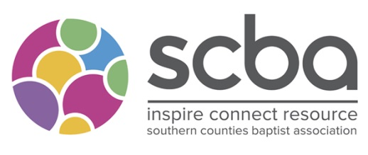
Regional Minister Opportunities
(2 Full-Time Equivalent Posts)

Following a strategic review and the calling of two existing regional ministers into new responsibilities, we are seeking to appoint in four areas:
Regional Minister - Operations Lead (0.5 FTE),
Regional Minister - Mission Development Lead (0.5 FTE)
Regional Minister (0.5 FTE) - General (50 or so ‘northern’ churches)
Regional Minister (0.5 FTE) - General (50 or so ‘south & eastern’ churches)

Full-time and part-time applicants welcome
We are seeking to appoint individuals who can make a distinctive contribution to our team and approximately 155 churches and pioneer projects in seeking to inspire, connect and resource healthy churches in relationship for mission.
We have a particular focus on developing the ‘local+’ participation and networking in mission and ministry of leaders and ministers across the Association.
We are open to God’s leading in the configuration of the new team, with the possibility that two of the roles could be part-time (minimum 0.5 FTE). We will seek to discern through the whole application and interview process how responsibilities may be shared.
We would be glad of a conversation about any of the roles. These can be arranged by contacting Colin Norris (SCBA Team Leader) via rmconversationwithcnorris@gmail.com
or Judith Wheatley (SCBA Interim Moderator) via moderator@scba.org.uk
Further details including descriptions of each role and the personal experience and gifts that we are seeking are available from our administration manager, Amy, via office.administrator@scba.org.uk
Applications to be sent to moderator@scba.org.uk by: Midday on Thursday 5th May
Interview date is expected to be: Monday 16th May

